Combinatorial Games
Topics
Games with simple rules: chomp, nim
Symmetry, exploiting it
Strategy, stealing it
Pairing
Connection: bridge-it, hex, graph, topology
Existential questions, winning strategies
Supersize my game

Intro
We want to find strategies to win in various games. It’s possible that there is a systematic way to find such strategies for all games, but we will first explore specific games.

For the first game, you can play against the computer here or against a human here and figure out the rules, or read this:
Chomp
Start with an m by n rectangle. 1st player picks a box and remove the boxes above and to the right of it including itself. 2nd player does the same. Repeat until a player is forced to pick the (poison) box in the lower-left corner, in which case he loses.

Exercise 1a: Play a few games (start with small rectangle first). Try different sizes (2 by n, n by n, 3 by 4, etc.)
1b: Is there a winning strategy for the 1st player (for special cases)?

Symmetry
The n by n case is easier than other cases because it is symmetric: [the first player picks the 2nd-from-the-left-and-2nd-from-the-bottom box, resulting in a (symmetric) L shape. Then the 1st player can win no matter what the 2nd player do. (how?)
He just imitates what the 2nd player pick on the other side of the L shape.]
Unfortunately, this only works for n by n. If we have an n by n+1 L shape, then the 2nd player can use his turn to make it a symmetric L shape and he wins. [This does give insights in finding strategies to win in the asymmetric cases nonetheless]

This method works for special cases of other games:
Nim (play against computer here)
Start with several stacks of stones. 1st player choose a stack and remove stones from that stack. Alternate until everything is removed and the last to remove wins.

Exercise 2: which cases does symmetry help?

[One of the cases is 2 stacks (1st player wins if and only if the stacks are uneven). A good tactic is to get pairs of stacks of even size.]

Strategy stealing
Back to Chomp, it turns out that [the 1st player always win]. But that doesn’t mean finding the strategy is easy (it gets tough starting with 3 by n). But there is an easy way to answer exercise 1b for all the cases:
Suppose the 1st player loses no matter what he picks and decide to pick the upper-right box. That means the 2nd player can move so that he wins no matter what the 1st player do. Play a second game of Chomp simultaneously, but this time the 1st player in game 2 imitates what the 2nd player does the first move in game 1(now both games have the same configuration, except that in game 2 you act like the 2nd player in game 1). Go on alternating between games by imitating the 2nd player in game 2 for game 1 and imitating 2nd player in game 1 for game 2. Then this shows 1st player must have a winning strategy (or else both player must have a winning strategy, but win/win is not possible).

This is quite neat although it doesn’t tell you how to win.
Some obvious things to not do: the 1st player must not remove an entire side, because the 2nd player becomes the 1st player in this configuration and has a winning strategy by the above result.

Exercise 3: What does the above paragraph say about the winning strategy for the 2 by n case?

[The 1st player needs to prevent 2nd player from making the configuration of a rectangle with an additional box (call it a jug), because he can only create a configuration of a rectangle with a row of at least 2 boxes sticking out, and then the 2nd player keeps on creating a jug, making him win. So the 1st player can win by creating a jug his first move.]

There are many other examples of this; symmetry of the board allows the 1st player in game 1 to copy the 2nd player in game 2. A similar technique works for chess (, which you can actually implement it):

Exercise 3b: If you are playing chess against 2 grandmasters, how can you prevent at least 1 from beating you?

Unfortunately, we can’t repeat the above argument to get the same answer (in chomp) for chess where someone has a winning strategy.

Why (exercise)?

[Because draw exists (chomp and many games are win/lose only), and the argument for chomp requires you to be the 1st player both times and the solution to 3b requires you to be 1st player in one game and 2nd player in the other.]

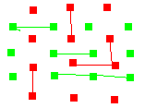
Draws
For some games it is not immediate that draw never happens

Bridge-it
Have an n by n+1 grid of green dots intertwined with an n+1 by n grid of red dots (see figure). Green connects horizontally or vertically adjacent green dots by a straight line and then red does the same for red dots. The paths of green cannot intersect the paths of red. Green wins if he forms a horizontal path and Red wins if he forms a vertical path.

Exercise 4: Play a few games of bridge-it. Which player wins easily? Why?

Why can’t both players win?
A winning path divides the board into two components for the opponent, whose paths have to stay inside a component.

Why can’t there be a draw?
Suppose the whole board is completely filled and red hasn’t won. Consider the red dots and lines starting from the top (all these are connected) and those from the bottom; these are two disconnected components. Green can then find a winning path squeezing between these two components, by going along the boundary of the top part.

Aside (topology and graph theory)
The connection of bridge-it, a game involving graphs, to connectedness, a topological concept, is seen above.
To get an extra taste of topology, consider

Hex (play against computer here)
It is played like bridge-it but on a hexagonal lattice, whose boundary has 4 sides of equal length (so it looks like a parallelogram) where the 1st player needs to find a path (of connected hexagons) connecting 2 opposite sides and 2nd player do the same for the other 2. Players alternate to select one hexagon at a time.

Again there can’t be a draw. Try convincing yourself informally. [It’s the same concept as bridge-it, but formally, finding a path would require more work.]

Consider this: Any continuous function f with domain and codomain being a 1 by 1 square (including the boundary) has a fixed point (x such that f(x)=x).

This is the (2-dimensional) Brouwer’s fixed point theorem, a important result in topology. Using the fact that there is no draw in hex, there is elementary techniques to find a fixed point for a continuous function (for more, click here).

Finally, first player has a winning strategy in hex (similar to exercise 3), but finding it for large games may be an open problem probably due to its (lack of) symmetry.

From the fact that there is no draw, we only need to prevent 2nd player from winning to win.
From exercise 4, you may guess that the 1st player has a winning strategy in bridge-it.

How?

Exercise 4b: Let say you are the 1st player playing two games against bridge-it grandmasters simultaneously. How do you steal the 2nd player’s winning strategy (supposing that it exists) from game 1 to win game 2?

[Symmetry of the board means you can imitate the 2nd player in game 1 by rotating the board in game 2 90 degrees, so if you lose in game 1 you must win in game 2.]

How about finding a winning strategy? If you have played a few games, it may seem easy to prevent the 2nd player from winning (which means 1st player wins).

Exercise 4c: give some vague tactics to prevent 2nd player winning. If you can, make them into a winning strategy.

A reasonable tactic strategy is to respond to the previous move by
(a) blocking that path to one side (going perpendicular).
But if he has paths on both sides of your incomplete blockade and is a move away from connecting those paths, of course you have to
(b) block the connection (going parallel).
But you may want to do both things at the same time.

One winning strategy involves:

Pairing
As the name implies, you pair up two moves and keep doing it until you pair up everything. The strategy is if your opponent makes one of the moves in a certain pair, you proceed with the other move in that pair (so you need to make sure the pairing is done right so the move you want to make in that pair is available). And of course, you want to pair to prevent the opponent from winning, which hard part.

Example: On a lattice, green and red take turns connecting horizontally or vertically adjacent dots with an edge of his color and the first to form a loop of his color wins. 1st player (green) has an advantage, but is it enough to guarantee a win? If not, how can red force a draw?

[To form a loop, you have to turn and one of the turn will look like an L. Pick a possible move and pair it with the move that combines to form an L. Repeat for the remaining moves. Since all L have two colors, there can’t be a loop with one color].

Exercise: On a checker board, green and red take turns placing a checker of his color on the board. To win you need to have a 2 by 2 square of your color. What should red do?

[Pictorially, it’s a brick house with each pair being a brick. Pick a row, pair the first two from the right and keep doing it as you move left. Green can’t bunch up at the first two, but can bunch up in the second and third. So for the next row above and below, pair up the second and third, and repeat as you move left.]

Pairing for bridge-it
So how do we pair moves up in bridge it (even without considering winning)?

[The blue dots in the figure below represent the available moves, which becomes unavailable after whoever move there first. So you want to pair the blue dots]
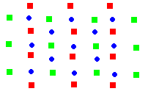
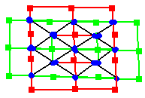
There are an odd number of moves, so remove a blue dot (which represents 1st player’s first move) before beginning to pair up dots.

If we now remove all the green and red dots, can you visualize a way to play the game involving blue dots only?
Here is how I would (the 1st figure on the right):
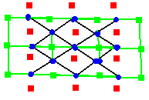
Consider the green, red and black bridges as part of the set up and the objective is the same, except that the blue area is unsafe to cross until it is claimed by green or red. Black bridges can be used by either player.
Since the center dot is heavily connected, it may be good for the first move.
Let’s now focus on green’s setup (assuming that green moves second. See 2nd figure) and red wants to find a pairing to block green.
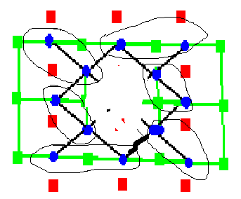
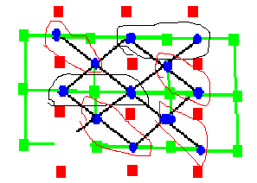
How should he pick? Try different ways to see what works.
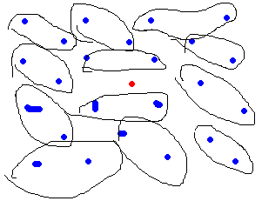
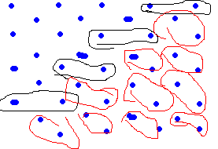
Adjacent blue dots are good candidates to pair up since this blocks one of possible paths. Also, it’s better to pair up horizontally, since this is where green wants to go. If you pair one diagonally, the rest of the diagonal pair near it should be in that direction because that keeps the opponent from moving forward (the figures below show negatively slopping diagonal pairs).
The figures show two methods to pair.
Bigger boards are also shown (fill in the rest).
You may prefer the second, which uses the corner for the first move instead.
Exercise: Do the pairings work?
How does the pairing (horizontal and diagonal) correspond to the tactics in 4c?

Some existential questions
It would be nice if some argument for a game (like chomp) works for other games (like chess). Let’s generalize slowly (chess is not included yet):
Consider all games which
- will finish in a finite number of moves
- has one winner and the other is the loser
Then we claim that: either the 1st or 2nd player has a winning strategy.

Proof: For all games that are finished in at most one move, either there exists or there does not exist a move that makes 1st player win, so the claim holds. For all games that are finished in at most two moves, making a move results in a game of at most one move, after which either the 1st or 2nd player has a winning strategy by the first sentence of the proof. So either there exists a move that makes it into a game of at most one move such that the 2nd player has a winning strategy or there isn’t, so the claim is true for games with at most two moves. Keep on inducting and we are done.

What happens if we change 2) to allow for draw? Then is it true that either the 1st or 2nd player has a non-losing strategy?

Let’s simplify by assuming (though not necessary)
- there is only finite number of choices for each move.

Then we can draw a game tree and put 1, 0 or -1 (called the payoff) at the end of each branch representing 1st player win, draw or 2nd player win, respectively.

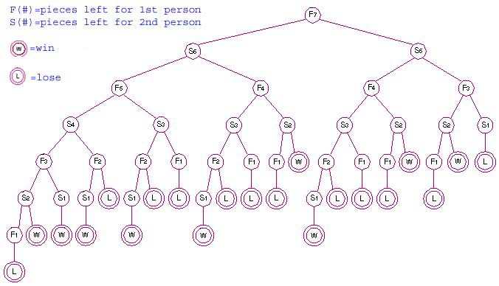

Exercise 5a: Who has a non-losing strategy for the game tree above? (L is -1, W is 1; the game is a variation of nim. More detail here)
5b: How about a much bigger game tree, do you have an algorithm to do it in general?

The analysis here is similar to that in game theory. (The scenario in game theory involves players moving simultaneously, so probability is needed to mix up several strategies to achieve optimal average payoff in the long run; then a non-losing strategy is not guaranteed.)

Suppose the game ends after n moves. Since there are only payoffs at the leafy end of the tree, which only helps you decide during the n-1 move to the n move, it’s hard to decide how to make the first move. It would be nice to have payoffs everywhere in the tree.
[We can move the existing payoffs (after n moves) up to get “payoffs” after n-1 moves, assuming the player playing that move plays optimally. So for example, if it’s the 1st player to move starting at a point after n-1 moves and the resulting payoffs are 0 and 1 after that move, the “payoff” before that move is 1. But if it’s the 2nd player, the “payoff” before that move is 0. Repeating this for points after n-2 moves, then n-3 moves and etc., every branching point will have a “payoff”. ]

Ex: Given a position, what does its “payoff” means?

[If it is 1, then if the 1st player move next, he can move to “payoff” 1 (but not higher), and if the 2nd player move next, he can move to “payoff” 1 (but not lower). So 1st player can get at payoff at least 1 because he can keep moving to a point with “payoff” at least 1, but if 2nd player didn’t screw up, it will be 1 and not higher. Similarly, 0 means, depending on who moves, the 1st (or 2nd player) can move to “payoff” 0 but not higher (or lower).]

The “payoff” at the starting position is called the minimax because it is the best payoff that player 1 can achieve with player 2 trying best to minimize it.

So what does this say about the existence of non-losing strategies?
If minimax is 0 or 1, that means no matter what player 2 does, player 1 will not lose (similarly for player 2 if minimax is -1 or 0).

Aside: For 2 players moving simultaneously, the minimax theorem claims that the minimax exists and can be achieved in the long run. Also the minimax will be a Nash equilibrium.

Chess
Can we apply the above result to chess? Not yet. Although there are only finitely many positions, it is an infinite game because positions can repeat.

How about making a new rule saying that repeating a position ends the game in a draw?
I think it should work. If you can win with this new rule, then you have forced a win without repeating a position, which is a win without the new rule. If no one can force a win with this new rule, then without the new rule, a player will repeats a position (if not, somebody can force a win with the new rule). Afterward, someone will repeats a position again (if not, the first position that was repeated doesn’t actually need to be repeated for someone to force a win, i.e. someone can force a win with the new rule). So we see it has to go on forever, which is really a draw.

The ultimate game
So far, we are not finding winning strategies systematically. A mathematician may find winning strategies for a game like chomp and relate all other games to it. But many games can be won by the 2nd player, unlike chomp, so chomp doesn’t seem general enough. We may generalize chomp so more games can relate to it.

How?

One way is to increase the dimensions (play with cubes instead of rectangles). But it is still a 1st-player-wins game (why?).

Another way is to allow the n by m rectangle to have infinite length or width. This is more interesting. Notice the type of infinity matters; suppose it is a 2 by infinity rectangle and suppose the 1st player’s move so that at least one of the infinite row become finite, then the 2nd player wins by making a (finite) jug (exercise 3). So if that infinity is the one that becomes finite no matter which box (and the boxes to the right of it) you pick to remove, then 1st player loses (define this type of infinity to be omega).

But if that infinity is not omega, but has 1 box to the right of the omega many boxes, then 1st player wins (since he can make it into 2 by omega with his move). This is omega+1, where 1 in the right means the extra box is in the right. It would be different if the extra box is in the left (1+omega=omega).

Generalizing games like nim this way (extending from natural numbers to ordinals) yields nice results: a large class of games is equivalent to nim.

Infinite games
We restricted attention to winning in a finite number of moves, but in allowing game boards to have infinite size (such as playing chess on an infinite board), it may be possible for a game with winning strategies only after infinite number of moves.

N-player games
Exercise 6: think of a way to generalize bridge-it if more than two people want to play.

[If there are n players, you need some n-dimensional lattices (n of them, each of which has all side lengths the same except one side is 1 unit longer) and then figure a way to arrange them nicely.]

Exercise 7: How about Hex?

[For the geometrically inclined, generalizing the hexagonal lattice to 3-dimension and higher may be a good idea. A different approach is to find a way to play hex on a checker board, so we can generalize simply by changing the board into an n-cube.] (Aside: the things said about 2-dimensional hex and Brouwer’s can be extended to n-dimension.)
Even though we haven’t learned much about how to win, let’s end here.

Reference
For more on a wide range of topics, the following expository book is excellent:
Luck, Logic & White Lies by Jorg Bewersdorff

A lot of the material comes from the first chapter of this text, which gives a systematic approach to finding winning strategies for certain classes of games:
Lessons in Play: An Introduction to Combinatorial Game Theory by Albert, Nowakowski and Wolfe

As you might have guessed, logic plays a substantial role in studying games (the section on chess). The following exposition with historical background has a little bit to offer for everyone:
Zermelo and the Early History of Game Theory, by Schwalbe and Walker

Finally, if you are not satisfied with any explanation above, Wikipedia will provide an alternative and it will introduce to you many new, related concepts.

